**Life-Saving Movable Platform Gates**

Abstract: -

Coming to my innovative idea my idea title is “**Life Saving Movable Platform Gates** “. It means Railway accidents reduce on the platform. In our daily life, we are observing so many train accidents like suicides and some people may suddenly fall causing the death. While the people going into the train and coming out of the train in the journey will happen by pushing. While children are playing on the platform and the drinkers will also slip suddenly and fall. For Example: - I want to share one incident with you. It happened in Vijayawada railway station. A 16-year-old boy along with his Parents was traveling from Vijayawada to Secunderabad. He alighted the train to buy a water bottle. When the train starts moving, he is afraid that he might miss the train. So, he ran towards the couch to board the moving train. At that time one head constable was on duty and he noticed a boy slipping into the gap. He immediately ran and dragged him out and that boy was out of danger with minor injuries.

Like that in Maharashtra and Rajasthan also took place. To reduce this kind of incident we want to implement this idea. To reduce the risk of accidents, especially from Several trains passing through the station at high speed and prevent accidents from the falling of the train between the gaps on to the lower track area by pushing. To overcome this problem, we are keeping a fencing gate beside the platform to fill the gap between platform and train.

Introduction: -

Railway accidents may be classified by their effects, e.g.: head-on collisions, rear-end collisions, side collisions, derailments, etc. And the injured people may not be able to lead a normal life easily thereafter. Also, the destruction of belongings leads to financial loss for the passengers. There are approximately 600 railroads, hundreds of thousands of miles of tracks, and over 209,000 railroad crossings.

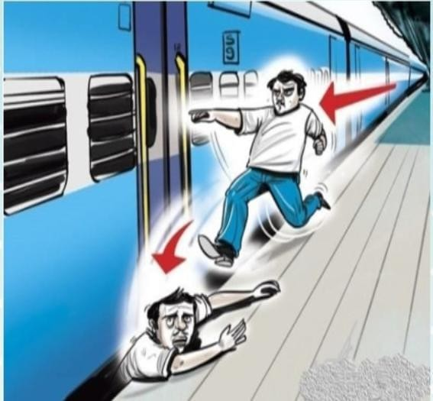

In 2014, there were 11,896 train accidents at railroad crossings, resulting in 804 fatalities and thousands of injuries over the cause of the year. Trains are estimated to kill 1 person every 100 minutes each year nearly 1,000 people are killed in train-related accidents. More than half of all railroad accidents occur at unprotected crossings and every case is unique, the most common causes of train accidents are happened by negligence, human error, and speedy trains. But the human error has always been one of the most common reasons for any accident. From poor judgment to vision issues to impaired reactions, these factors can contribute to training disasters and some people choose to take their own lives by standing on the tracks or jumping in front of a train. Federal statistics show that 266 people killed themselves by stepping in front of trains and there are some many accidents for this we are keeping fencing gates.

Working: -

In our daily life so many Railway accidents on the Platform. It means people's negligence in cases of minor injuries or death. So, we are careful to goes railway journey. In Japan, We use PSD (platform screen doors) in the Metro Station. So, we are protecting the people's lives in a busy schedule. That means we are going to market, office, works, etc.,

**Platform screen doors** (**PSDs**), also known as **platform edge doors** (**PEDs**), are used at some [train,](https://en.wikipedia.org/wiki/Train) [rapid](https://en.wikipedia.org/wiki/Rapid_transit) [transit](https://en.wikipedia.org/wiki/Rapid_transit) and [people mover](https://en.wikipedia.org/wiki/People_mover) stations to separate the [platform](https://en.wikipedia.org/wiki/Railway_platform) from train tracks, as well as on some [bus rapid](https://en.wikipedia.org/wiki/Bus_rapid_transit) [transit,](https://en.wikipedia.org/wiki/Bus_rapid_transit) [tram](https://en.wikipedia.org/wiki/Tram) and [light rail](https://en.wikipedia.org/wiki/Light_rail) systems. They are primarily used for passenger safety[.[1]](https://en.wikipedia.org/wiki/Platform_screen_doors#cite_note-1) They are a relatively new addition to many metro systems around the world, some having been retrofitted to established systems. They are widely used in newer [Asian](https://en.wikipedia.org/wiki/Asia) and [European](https://en.wikipedia.org/wiki/Europe) metro systems, and [Latin American](https://en.wikipedia.org/wiki/Latin_America) bus rapid transit systems.

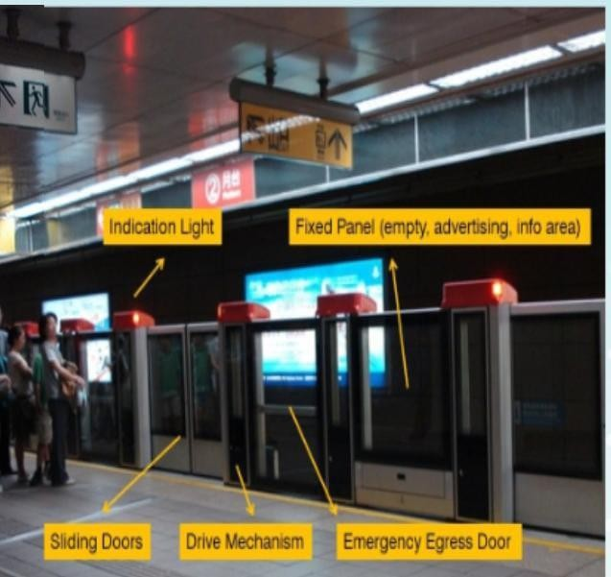

Although the terms are often used interchangeably, **platform screen doors** can refer to both full- height and half-height barriers. Full height platform screen doors are total barriers between the station floor and ceiling, while the half-height platform screen doors are referred to as **platform edge doors**, as they do not reach the ceiling and thus do not create a total barrier. Platform gates are usually only.

half of the height of the full-screen doors, but they sometimes reach to the height of the train. These two types of platform screen doors are presently the main types in the world. In the platform

screen doors are.

* Automatic platform gate
* Rope-type screen doors

Automatic platform gate: -

Half-height platform doors, or **automatic platform gates**, are chest-height sliding doors at the edge of [railway platforms](https://en.wikipedia.org/wiki/Railway_platform) to prevent passengers from falling off the platform edge onto the [railway tracks](https://en.wikipedia.org/wiki/Railway_tracks). Like full-height platform screen doors, these platform gates slide open or close simultaneously with the train doors.

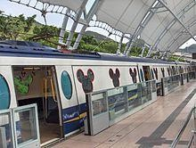

Rope-type screen doors: -

There are also rope-type platform screen doors, initially installed in some stations in South Korea and Japan, where multiple train types with different length and train door structures use the same platforms. The barriers move upwards, rather than sideways, when letting passengers through.

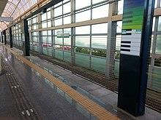

In the same Process, we are also arranging the platform gates to a Railway Station. We arranged the two cases of gates if the train speed is less than to 10km/h is gates will be down position and also the train speed is greater than to 10km/h is gates will be up position.

For suppose when the train is away from the station at 2km. It gives induction whether the train is stopped (or) not. If the speed of the train is equal to 10km/h or less than 10km/h. Then the sensor will detect the gates in standing position when the train comes near to the platform at that time the gates will be down one by one. If the train will be greater than 10km/h. At that time the gates will be in standing position only. This total method depends upon the speed of the train. By using the speed formula.

Case – 1:-

If the train is away from the Railway station at 2km. If the

train speed is less than 10km/h,then all platform doors are up

position When the train engine reaches the platform. If the

platform doors are opening based on the train engine and LVB

(Last Vehicle board). If the Railway station between train

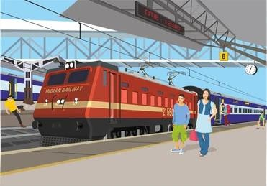

engine and LVB of doors are down position.

Case – 2: -

If the train is away from the Railway station at 2km. If the train speed is greater than 10km/h then all platform doors are up position.

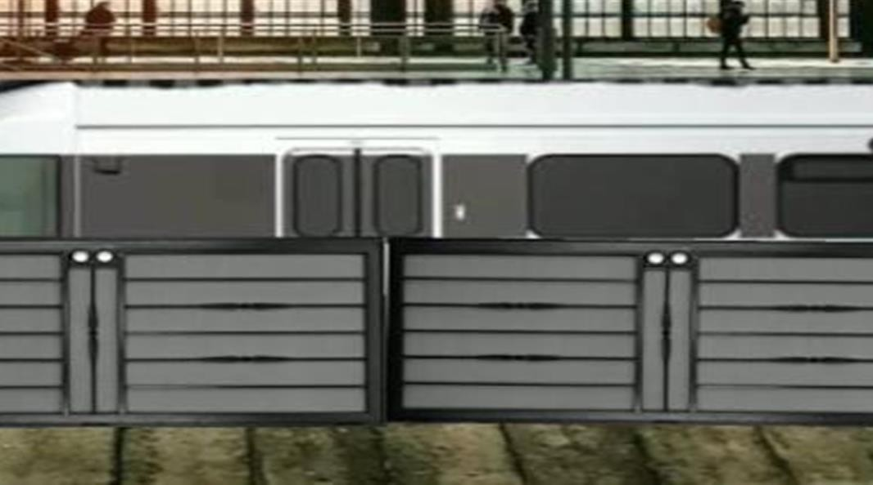

Prototype components: -

* 12 volts DC Power Supply
* 12 volts DC Motor Speed Controller
* 12 volts 60 RMPS DC motor
* Hitech Plastic DIY Rack and Pinion
* Wood

Working: -

For prototype purposes, we are taking a single gate. In this, there are also two cases.

Case-1: -

If the speed of the train is less than 10 km/h or equal to 10 km/h, then the gates will go down.

Case – 2:-

If the speed of the train is greater than 10 km/h & if there is no train, the gates will be in the up position only.

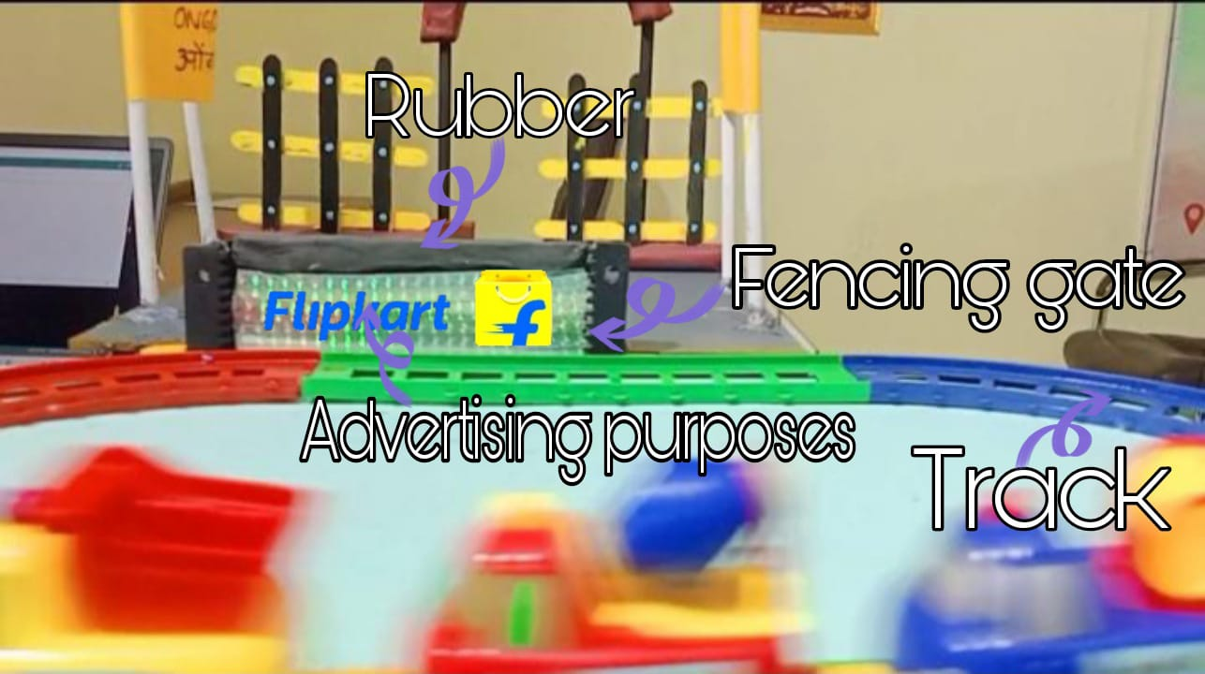

* On top of the gate, there is rubber for protecting the passengers, and it is adjusted to the train facility.
* Sliver screening for advertising purposes

Conclusion: -

* To save the lives and reduces the train accidents and we want to develop this in railway stations.
* To increase the income of central government.
* To increase the stations and trains.
* To increase the transportation and logistics.